33 a. 2022
Verona, 11 April 2022

Press release
MSCA Postdoctoral Fellowships, €1.4 million EU funding
to support six young researchers

Six researchers have chosen to carry out their project in Verona as part of the Marie Skłodowska-Curie Actions (MSCA). Named after the first woman to win a Nobel Prize, MSCA is the EU's flagship funding programme under Horizon Europe for doctoral education and postdoctoral training. This is the first time that the University of Verona has hosted such a large number of young MSCA Fellows for a total funding of 1.4 million euros.

Please find below a short bio of the new six MSCA Postdoctoral Fellows:
Giulia Battistoni is an expert in classical German philosophy, a fellow at the Italian Institute for Historical Studies and author of several national and international publications. In Verona, she will study how to develop a collective and proactive concept of "responsibility" towards nature and future generations, starting from the German philosophical definitions originated between the 19th and 20th centuries. This project will be supervised by Prof. Giorgio Erle, Professor of Moral Philosophy at the Department of Human Sciences.
Astrid Dröse’s research focuses on literature, music history and gender studies in German modern culture at the Eberhard Karls Universität in Tübingen. Her research project aims to overturn the traditional representation of the so-called 'Age of Goethe' through a methodologically innovative analysis of the major journals of the time. The project will be supervised by Prof. Laura Anna Macor from the Department of Human Sciences.
Federico Micolucci, a research fellow at the University of Gothenburg, gained expertise in the development of pilot plants for the production of bioproducts and biopolymers from organic waste substrates during his MSc and PhD studies. His project, supervised by Dr. Nicola Frison from the Department of Biotechnology, will aim to transform wastewater treatment plants into resource recovery treatment plants, using organic matter from wastewater as raw material.
Davide Papola has worked and collaborated with several research centres and international agencies since 2012, including the World Health Organisation, the Italian Medicines Agency, the Italian National Institute of Health, McMaster University in Canada and the Vrije Universiteit in the Netherlands. His ‘Re-shift’ project, which will be supervised by Prof. Corrado Barbui from the Department of Neurosciences, Biomedicine and Movement Sciences, will investigate mechanisms for the treatment and prevention of anxiety and depressive syndromes in populations living in low-resource settings.
Joanna Raisbeck was educated at Oxford University where she works: her research focuses on literature and intellectual history in the German area between the 18th and 19th centuries. With her project she now intends to promote a new image of the golden age of German literature and philosophy. Key to this will be the material and social processes of production and reception of culture, such as the practice of emotions, women's literary networks and popularity among the general public. The project will be supervised by Prof. Laura Anna Macor from the Department of Human Sciences.
Krystyna Wieszczek is an English literature expert working at the University of Bologna and the Jesuit University Ignatianum in Krakow: her research interests focus on literary reception, translation and censorship. Her project aims to find out if and how reading can help improve empowerment and thus contribute to a better quality of life and mental wellbeing of readers. Her project will be supervised by Prof. Massimo Salgaro from the Department of Foreign Languages and Literatures.

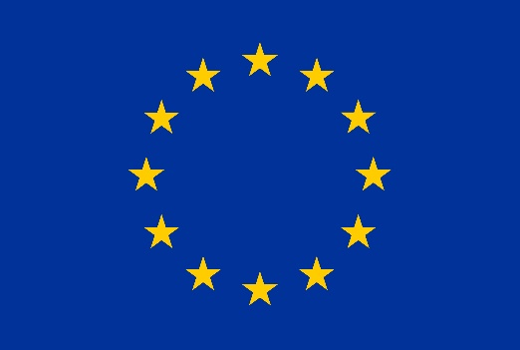

Press Office
Roberta Dini, Elisa Innocenti, Sara Mauroner
+39 366 6188411 - +39 3351593262 - +39 3491536099
ufficio.stampa@ateneo.univr.it
Agenzia di stampa Univerona News

